**Abstract**

Landscape component could provide important information for ecologists to find hotspot habitat in habitat protection. The encounter probability model based on spatial capture-recapture model is developed and used in this paper to analyze role of each landscape component in our study. This encounter model uses Euclidean distance between pixel location and individual activity centroid to calculate the encounter probability for each pixel, with extension of landscape covariate adding to the model. We use GLM Poisson encounter model to estimate the association of two landcover components with individual space usage in study of nine species leopard near South Africa. The result of our model shows how do elevation and landcover component affect leopard space usage. The model is based on the assumption of independent individual space usage; therefore, when individual’s movement in habitat violate the assumption this model is not working. Further improvement could be the analysis of individual movement, improved model could provide additional information based on individual movement across pixels.

**Introduction**

Animal habitat protection is very important; and habitat destruction could cause bad effect to human. (Primack 2006) To allocate human facilities for financial benefit and protect wild animals’ habitat simultaneously, it is necessary to consider moderate development in wild area. A good way to achieve this allocation and protection is making habitat conservation, during human development near wildlife habitat. In habitat conservation, identifying priority habitat area to conserve and protect is the first matter to consider. But the research of determining size, type and location of habitat is pretty hard and complex in biology field. (Hierfl 2008) In traditional identifying approach, hotspot areas are identified from observations data; this method could not precisely estimate the location of habitat because some animals such as leopard and condor tend to move in large area space, some locations in their activity area are not very important to be considered. In order to find the hotspot region for wild animals efficiently, some landscape parameters in that habitat could be estimated and analyzed to help find the real important habitat for animals; for instance, panda tend to live in those area where bamboo exists and scientists could estimate panda’s habitat according to the distribution of bamboo. Those landscape parameters which highly relate to species movement and density could be analyzed and referred during habitat protection. Thus, the relationship between different environment element and animal should be estimated.

Spatial capture-recapture model, which is applied widely in animal population density study, uses encounter probability model to estimate the encounter probability by function of Euclidean distance and make spatial analysis in density research. (Efford *et al*. [2009](https://besjournals.onlinelibrary.wiley.com/doi/full/10.1111/2041-210X.12039#mee312039-bib-0007); Gardner *et al*. [2010](https://besjournals.onlinelibrary.wiley.com/doi/full/10.1111/2041-210X.12039#mee312039-bib-0014); Gopalaswamy *et al*. [2012](https://besjournals.onlinelibrary.wiley.com/doi/full/10.1111/2041-210X.12039#mee312039-bib-0016); [Royle *et al*. 2013a, b)](https://onlinelibrary.wiley.com/doi/full/10.1111/j.0030-1299.2004.13043.x#b1) Spatial capture-recapture model could avoid the bias in density study comes from undefined effective trapping area; and SCR model could estimate animal density based on repeated animal observation data from multiple traps, which is easier and cost less compared with long-time period individual observation data. Royle (2013b) introduces a new model relate to spatial capture-recapture model to solve the problem that encounter probability model in SCR model causes the home range of animal activity to become too stationary and too symmetric because of the lack of landscape effect analysis; by extending landscape covariate parameters into encounter probability model function, Royle’s SCR model could analyze animal space usage with environment influence and predict animal population density with landscape connectivity simultaneously.

In this paper, we use the SCR model in a different purpose, by fitting model based on animal density data to find relationship between animal count and landscape covariates in SCR model. By the reverse usage of Royle’s SCR model, it is possible to find the role of each landscape parameter in animal habitat. Some important information about landscape effect could be given from the estimated coefficient of each landscape parameters in the encounter probability model. The analysis of landscape effect in this method we developed in this paper could solve three important questions: (i) it determine what kind of environment component is important for animal species to live in its habitat and what kind of landscape element is not important to live; (ii) it estimate how does these kinds of landscape components influence animal’s activity selection (positive effect or negative effect) (iii) it calculate the extent of the impact to wildlife from these landscape covariate. (strong effect or low effect) The key concept in our paper is using spatial capture-recapture model to find how do environment components influence animals and how do animals use their habitat.

In following section, we introduce the SCR model for density study, with discussion of basic SCR model and Royle’s(2013b) SCR model with landscape covariate in encounter probability model. Then introduction of the reverse usage of the SCR model for landscape parameters also be discussed in “Poisson model” section. After that, we show the application of this new model to study the landscape effect on leopard in African habitat. Eight different leopard species activity GPS location data is recorded by several traps in their habitat, with some spatial-referenced data covering in that area (elevation and landcover). The result of this application shows how does each landscape element effect eight leopard species to use their habitat, and offers suggestions to protect this leopard habitat.

**Literature review**

This literature review offers threads from which theory and insights could be woven, including efficient method in animal population density study, problems and solutions in classical animal density study and spatial capture-recapture study, research on encounter probability study and effective method to connect animal density study with landscape covariates. This chapter reviews most relevant studies for each thread in animal population density study. Each thread is related to the topic of this article, but also these streams has some problems that could be improved. Royle ‘s research (2003) argues a new way in animal density research which could deal with heterogeneity problem and could achieve financial benefit. Research by Efford (2004), Borchers (2008) and Royle (2008) focus on the problem of undefined effective trapping area, and each research state new method to solve this problem. Studies by Rolye (2013a, b) concentrates the analysis that connect animal space usage in spatial capture-recapture model with environment effect on animals. To conclude, this literature review shows traditional capture-recapture model in animal density study could not contain landscape effect in density study, and that is the method in this research addressed could solve.

For Biologists, animal population density is one of the most important parameters in animal population study. (Krebs 1985; Turchin 1998) And collecting animal population data from traps might be the most common method in animal population density analysis. ([Thompson *et al*. 199](https://onlinelibrary.wiley.com/doi/full/10.1111/j.0030-1299.2004.13043.x#b54)8) Capture-recapture method is a normally used method for population size study (Borchers & Efford [2008](https://besjournals.onlinelibrary.wiley.com/doi/full/10.1111/2041-210X.12039#mee312039-bib-0003)). Royle (2003) introduces such method to estimate occupancy rate when heterogeneity in trapping probability exists. The basic idea in the method is that the detect probability could be affected by the variance of abundance. From this method, scientists could estimate animal abundance distribution by making model of heterogeneity detection probability. This method could accept animal data from repeated trapped records instead of unique individual population document. (Royle & Nichols 2003) By using this method an animal population research could do several times and save large amount of money during recording observations. In this capture-recapture method, population size could be converted to or treated as density, by dividing effective trapping area; however, effective trapping area could be very hard to calculate (Efford 2004). Dice (1938) suggests the distance from the traps W could be used to calculate the effective trapping area. There also exist some other ways to get trapping area, but none of these methods are commonly used or strongly reliable. (Efford 2004) Several method to avoid effective area in population study, like trapping webs ([Anderson et al. 1983](https://onlinelibrary.wiley.com/doi/full/10.1111/j.0030-1299.2004.13043.x#b1)), require specific trapping conditions and these method have less reliability to scientists in study of population density for most cases. (Efford 2004). In Parmenter’s study (2003) about the density estimation of rodent from 11 data sets, the author compares grid-based density estimation method and web-based density method with given density value datasets. Both methods require several assumptions of the datasets, and the results of two method seems met the assumptions. The result of this study shows most web-based method shows better accuracy than most grid-based method; the best web-based method shows comparable performance to best grid-based method; the method using “effective trapping area” shows lack of performance in rodent density study, but the application of rodent movement distance improves the performance of density estimation a lot. The web-based method seems has good performance than grid performance, but web-based method requires several assumptions and well-defined effective trapping area. Therefore, a good performance of trapping web method needs the good measured trapping area, which is hard to estimate for most studies.

To solve the problem of lack efficient way to define and estimate effective sampling area, Efford (2004) argues a new method in his study to estimate density from capture and recapture animal population data without the step of calculating effective trapping area, by using a two- parameter spatial capture function to make a simulating model and do simulation and inverse prediction to estimate population density. During the research, his method provides an unbiased estimate of population from simulation data. (Efford 2004) There are some problems appear in his method when trap saturation level becomes high enough and when trap competition happens, and this method has some limitations in model selection and covariates analysis. (Borchers & Efford [2008](https://besjournals.onlinelibrary.wiley.com/doi/full/10.1111/2041-210X.12039#mee312039-bib-0003))

A very similar method relate to Efford’s method is the Spatially Explicit Maximum Likelihood Methods developed by Borchers (2008), this method solves the problem that capture-recapture method has lack of ability to analyze spatial nature during population density study. In capture-recapture study, spatial component could affect the trapping progress; traps could record animals closer to the trap with more probability than record animals far from trap. This problem is not solved in previous population estimate study and may cause the result not reliable enough for spatial density analysis. (Borchers & Efford [2008](https://besjournals.onlinelibrary.wiley.com/doi/full/10.1111/2041-210X.12039#mee312039-bib-0003)) The new method could achieve spatial nature analysis by estimating animal spatial probability from animal location and trap location based on maximum likelihood; by adding spatial components into model, the density estimation could be “well defined” because of the population abundance could be defined.

The other problem in animal density study from close populations is the existence of population movement, most in short terms; this will cause effective population area changes and makes estimate result not strongly reliable. (Royle & Young [200](https://besjournals.onlinelibrary.wiley.com/doi/full/10.1111/2041-210X.12039#mee312039-bib-0032)8) Royle’s new method (2008) based on capture-recapture data involves a hierarchical model calculating with sample spatial unit area, then individual activity center and individual activity movement could be estimated by hierarchical model. The density of individuals could be estimated by this method, and the problem of population movement could be solved.

For these three methods, one common part in their research is the application of spatial capture-recapture method. The elementary theory in spatial capture-recapture method is use function which contains distance between animal individual location center and the trap location to get encounter probability. (Borchers & Efford [2008](https://besjournals.onlinelibrary.wiley.com/doi/full/10.1111/2041-210X.12039#mee312039-bib-0003)) This method makes it is possible to finish spatial population density research. Although spatial capture-recapture models are new class of method, the use of it is relatively widespread in population density and movement estimation. (Efford *et al*. [2009](https://besjournals.onlinelibrary.wiley.com/doi/full/10.1111/2041-210X.12039#mee312039-bib-0007); Gardner *et al*. [2010](https://besjournals.onlinelibrary.wiley.com/doi/full/10.1111/2041-210X.12039#mee312039-bib-0014); Gopalaswamy *et al*. [2012](https://besjournals.onlinelibrary.wiley.com/doi/full/10.1111/2041-210X.12039#mee312039-bib-0016); [Royle *et al*. 2013a, b)](https://onlinelibrary.wiley.com/doi/full/10.1111/j.0030-1299.2004.13043.x#b1) Efford (2009) used a new spatial capture-recapture model to find animal density of close-population with stable home range, the author also introduces a new longtime single sampling interval which has some financial benefits compared to previous sampling time intervals. Gardner’s hierarchical spatial capture-recapture model (2010) uses spatial explicit components of black bear detected by traps to make analysis on black bear. Gopalaswamy (2012) makes a comparison capture-recapture research on tiger density, tiger photographic data analysis and tiger fecal sample analysis. According to the result of the research, making inference on parameters from more information could improve the model, SCR model could be improved by adding more landscape information to the model. The widely application of spatial capture-recapture model comes from spatial capture-recapture’s ability to solve critical problems in non-spatial capture-recapture method (Royle *et al*. 2013a, b) such as the heterogeneity in encounter probability from juxtaposition of individuals with traps and ill-defined sampling area. (Borchers 2012; Royle *et al*. 2013a, b) The axillary spatial information produced by capture-recapture research is also a benefit of using spatial capture-recapture method.

Despite the widely utility of spatial capture-recapture method in population density analysis, Royle (2013b) points out the encounter probability model makes the estimation of space becomes too stationary and too symmetric to represent animal’s spatial resources selection. The encounter probability model, which most capture-recapture model based on, uses Euclidean distance to calculate encounter probability by simple functions in spatial capture-recapture model; some different encounter models are proposed in resent year including binomial, Poisson and multinomial encounter models.(Royle *et al*. 2013a) The encounter probability model implies stationary and symmetric animal home range, which is unreasonable because animal will make temporally movement decision by environment effect; for example, water buffalos tend to move to areas where has plenty of water and leopards prefer those area which is their prey habitat. The function in encounter model can’t achieve analysis of landscape effect nor get encounter probability which influenced by resources. Even though such stationary distribution could show good performance in some sparce data, for most cases these simple encounter probability models can’t represent animal home range size and shape for animal’s unevenly spatial resources selection. (Royle *et al*. 2013b) The location where animal lives on and the state of surrounding environment could affect animal spatial usage, so the encounter model should countian irregular and non-stationary properties on animal home range and could deal with local resource effect.

Landscape connectivity, which define as the level of landscape components affect animal movement ([Tischendorf and Fahrig 2000](https://esajournals.onlinelibrary.wiley.com/doi/full/10.1890/12-0413.1#i0012-9658-94-2-287-Tischendorf1)), is recognized widely to become the population viability’s importance element. ([With and Crist 1995](https://esajournals.onlinelibrary.wiley.com/doi/full/10.1890/12-0413.1#i0012-9658-94-2-287-With1)) In ecological research, ranking the landscape connectivity in animal density effect is one of the most important properties. (Royle *et al*. 2013a) In previous research, scientist normally estimate landscape connectivity values based on expert’s subjective opinion or some temporary method.  ([Adriaensen](https://esajournals.onlinelibrary.wiley.com/doi/full/10.1890/12-0413.1" \l "i0012-9658-94-2-287-Adriaensen1) *[et al.](https://esajournals.onlinelibrary.wiley.com/doi/full/10.1890/12-0413.1" \l "i0012-9658-94-2-287-Adriaensen1)* [2003](https://esajournals.onlinelibrary.wiley.com/doi/full/10.1890/12-0413.1" \l "i0012-9658-94-2-287-Adriaensen1); [Beier](https://esajournals.onlinelibrary.wiley.com/doi/full/10.1890/12-0413.1" \l "i0012-9658-94-2-287-Beier1) *[et al.](https://esajournals.onlinelibrary.wiley.com/doi/full/10.1890/12-0413.1" \l "i0012-9658-94-2-287-Beier1)* [2008](https://esajournals.onlinelibrary.wiley.com/doi/full/10.1890/12-0413.1" \l "i0012-9658-94-2-287-Beier1); [Zeller *et al.* 2012](https://esajournals.onlinelibrary.wiley.com/doi/full/10.1890/12-0413.1#i0012-9658-94-2-287-Zeller1)) The lack method to predict animal density and landscape connectivity values simultaneously makes it becomes very hard to predict the effect of landscape in animal density study. This problem could cause huge bias exists in population density estimation result.

Royle (2013a) develops a model based on spatial encounter probability with alternative distance which could represent connectivity, Royle calls it “ecological distance”. This distance is related to the least-cost path with cost-weighted distance metric, and could define the distance between animal activity center and traps in cost-weight metric. The ecological distance could be calculated from the cost of moving between different cells in sample data and consider some environment variables that could affect animal movement between two cells during calculation, like elevation, snow cover, landcover and range limitations. ([Cushman *et al.* 2006](https://esajournals.onlinelibrary.wiley.com/doi/full/10.1890/12-0413.1#i0012-9658-94-2-287-Cushman2); [Schwartz et al. 2009](https://esajournals.onlinelibrary.wiley.com/doi/full/10.1890/12-0413.1#i0012-9658-94-2-287-Schwartz1); [McRae and Beier 2007](https://esajournals.onlinelibrary.wiley.com/doi/full/10.1890/12-0413.1#i0012-9658-94-2-287-McRae2)) By using such distance, the landscape structure influence could be added to the spatial density analysis; and the parameters of cost-weight distance could be calculated and used directly in spatial capture-recapture method to connect the animal spatial density with landcover covariates. From the result of Royle’s simulation study (2013), the model use Euclidean distance produces huge bias while the model with least-cost path distance has better result. One problem of this method is that it cannot estimate the precise location of animal’s path of movement and the decision of animal when they move in different landscapes. (Royle *et al*. 2013a)

Second model that could deal the spatial capture-recapture process with animal’s space usage states by Royle (2013b); he improves the spatial capture-recapture model by add one or more clear landscape covariates to encounter probability model, this could extend the model with space usage and resources selection. By extending the model with some landscape covariates, those unpresented elements in previous encounter probability model such as animal home range size and shape could be included in Royle’s new model, and the new model could relate capture-recapture analysis with the trend of animal space usage. The new model also avoid bias during estimating process, especially in those situations where landcover covariates could influence animal spatial usage and selection. (Royle *et al*. 2013b)

According to previous research about animal population density research (Efford 2004; Borchers & Efford [2008](https://besjournals.onlinelibrary.wiley.com/doi/full/10.1111/2041-210X.12039#mee312039-bib-0003); Royle & Young 2008; Royle *et al*. 2013a, b), spatial capture-recapture method could be used in animal population density analysis because it has financial benefits compared to previous trapping method and it could solve the problem in classical non-spatial methods. And the application of encounter probability model in spatial capture-recapture model could avoid the problem of undefined sample trapping area and deal with spatial elements in population density study, which are two big problem in traditional population density analysis method; however, the encounter probability model might cause some problem in estimation from animal density data with landscape effect, since the encounter model could not connect to the animal home range with around landcover situations. Because of the limit of analysis for animal surrounding environment components in encounter probability model, the animal home range estimations from the model function show stationary and symmetric nature and causes the estimation unable to represent environment effect in density study. Thus, it is necessary to add landscape covariates in spatial capture-recapture model to provide connection between animal spatial components and landcover resource elements. This method could improve the estimation of density when landscape covariate has influence on animal spatial movement and usage, and could provide landscape effect analysis in animal population study.

**Spatial capture-recapture method**

Spatial capture-recapture method is a new method to estimate animal population density information from individual capture-recapture location data. (Royle *et al*. 2013b) The key concept in Spatial capture-recapture method is using a function based on the distance between trap location and animal activity center to find the encounter probability. The trap location (x) is each individual trap location in capture-recapture data and the activity center (s) could be the home range of an individual, calculating by taking average of that individual’s trapping location during one time period. (Royle *et al*. 2013a) The introducing of spatial component in capture-recapture method makes the model to avoid bias in estimating abundance by modeling least trapping individual, and makes the model deal with the condition when capture probability depends on locations. Model based on spatial capture-recapture method could solve all problems of close population capture recapture study, such as problems with observable or unobservable heterogeneity and behavior response. (Borchers & Efford 2008)

There exist many models to estimate encounter probability in spatial capture-recapture study, including Poisson model, binomial model and multinomial model. (Borchers & Efford [2008](https://besjournals.onlinelibrary.wiley.com/doi/full/10.1111/2041-210X.12039#mee312039-bib-0003); Efford *et al*. [2009](https://besjournals.onlinelibrary.wiley.com/doi/full/10.1111/2041-210X.12039#mee312039-bib-0007); Royle *et al*. [2009](https://besjournals.onlinelibrary.wiley.com/doi/full/10.1111/2041-210X.12039#mee312039-bib-0031)) In binomial encounter model, we suppose there has j traps so we have xj trap locations; and we suppose we have i observation individuals in capture-recapture data; thus, we have total Nij amount of observation records based on number of individuals and traps. For individual i, the vector Ni = (ni1, ni2, ……, nij) forms the encounter history of this individual. From the observation nij, we could make gaussian model that contains a binomial function to get encounter probability pij, which is a standard encounter probability model. (Borchers & Efford 2008)

. (eqn 1)



This function could also be written as, (Royle et al. 2005)

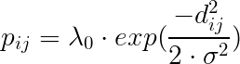 (eqn 2)

where dij is the Euclidean distance between trap location xj and individual activity center si,



and let 𝛼0=log(𝜆0) and 𝛼1= 1/(2×𝜎2). By changing format of equation 2, pij could be represented as,

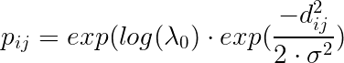

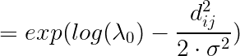

and we replace log(𝜆0) by 𝛼1 and replace 1/(2×𝜎2) by 𝛼1, we will get pij in which,

. (eqn 3)



This model based on a basic assumption that the Euclidean distance in standard encounter model is stable and can’t be influenced by other variables like environment components, this means it assumes all individuals here have stational and symmetric home range and individuals move in same circular spatial format in their habitat, which is irrational and unreasonable under real condition. In fact, landscape component and habitat condition could affect animal activity and cause them to change their space usage. Because of this, an irregular and non-stational home range is required in population density study and could accommodate real habitat environment. The new model should react sensitively to different spatial landscape conditions and estimate individuals space usage according to landscape covariates from surrounding area.

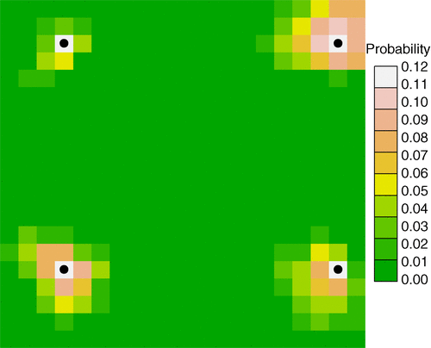

**Figure 1**

Typical home ranges for four individuals in the fragmented landscape.

(Royle *et al*. 2013a)

This plot shows 4 individual activity center and their encounter probability in pixels. From the color of each pixel we could read the home range of each individual. The activity center sometime doesn’t exist in the pixel that individual uses highest or the center of their activity area. The plot of one individual trap observation shows its activity center and the frequency of usage for each pixel.

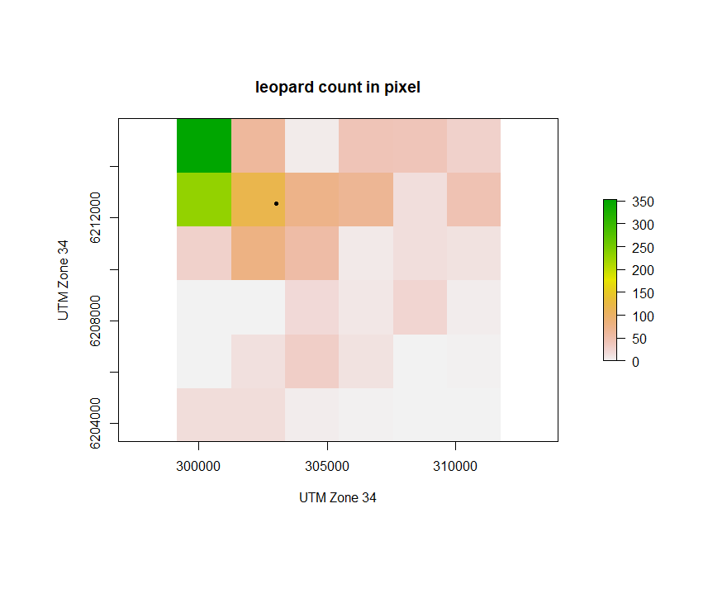

**Figure 2**

One leopard home range plot with activity center.

**Model of space usage**

The new method only focuses on spatial usage of individuals instead of their activity pattern, so we only need to model the result of observation data from traps and don’t need to analyze animal’s movement process. (Royle *et al*. 2013b) Here we define the data from as raster data for individual locations and landscape covariates. Suppose we have n pixels in our raster data, xj = (x1, …, xn) is the center coordinate of that set of pixels in our data, and this set of xj could be recognized as the trap location in section “Spatial capture-recapture method”. Individuals’ space usage in habitat is defines as their location record in pixels from observation raster data. Then we define z as the covariate of landscape (elevation or water cover) in our raster; we could add more than one landscape covariate and we will talk about it later.

In Multinomial assumption, let p(xj) represents the probability of individual to use j pixel, which,

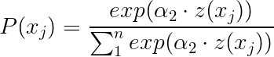 (eqn 4)

is the standard RSF model according to Manly’s research (2002). Coefficient 𝛼2 represents the influence of landscape covariate to the probability of pixel usage. The probability of pixel usage will increase as z(xi) increase when the positive landscape coefficient 𝛼2 exists. Then we extend equation 4 to make probability model for individual space usage of each pixel with the activity center of individuals i, in which (Johnson *et al*. [2008](https://besjournals.onlinelibrary.wiley.com/doi/full/10.1111/2041-210X.12039#mee312039-bib-0021); Forester *et al*. [2009](https://besjournals.onlinelibrary.wiley.com/doi/full/10.1111/2041-210X.12039#mee312039-bib-0011)),

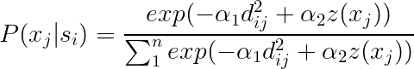 (eqn 5)

xj is each pixel coordinate, si is the activity center of individual and dij is defined as the Euclidean distance between the activity center to pixel xj. This function describes the relationship between encounter probability for individual (also the probability of pixel usage with activity center) with the distance of pixel to activity center and landscape covariate. When 𝛼1 is positive, as the distance of pixel and activity center increases the encounter probability decreases and when positive 𝛼2 exists, the value of landscape covariate z(xj) increases the probability increases. Thus, the equation could be simplified to:

 (eqn 6)

If we set 𝛼2 to 0, representing there has no environment effect to encounter probability, equation 5 will change to:

.



**Poisson model**

Under the assumption that result of pixel usage is independent and has Poisson distribution, we could use Poisson spatial capture-recapture model. Define the result of the pixel usage by individuals (how many times individual uses each pixel) as N(xj), when individual moves randomly in habitat, we have Poisson SCR model (Royle et al. 2013b):



in which xj is location of j pixel and si is the activity center of individual i, then:

. (eqn 7)

The encounter probability P(xj|si), which is the probability of usage in pixel j for individual i, could be represented by:

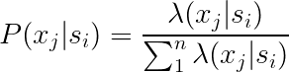

and then we could transfer it to function based on equation 7:

 (eqn 8)

The RSF model in Poisson model is same as the RSF model of multinomial model. In Equation 8, 𝛼0 is the intercept, 𝛼1 is parameter for distance from pixel to individual activity center and 𝛼2 is parameter for landscape covariate; this function shows the distance dij and landscape covariate affect individual space usage. When 𝛼1 is negative and 𝛼2 is positive, as distance and landscape covariate increase the encounter portability increases. In this paper we use this glm Poisson model based on this equation to model encounter probability from eight leopards individual location data. After we fit the model for encounter probability, we could find the relationship between landscape covariate parameters with leopard space usage. If we find the coefficient of the landscape 𝛼2 is negative, that means this landscape component has negative effect on individual. The bigger 𝛼2 value is, the stronger influence this component has on individual. From analyzing the coefficient, we could get information about connection of animal with it surrounding habitat condition, and help to protect habitat more efficiently.

**Application: South Africa leopard study**

The GLM Poisson spatial capture-recapture model is applied in our study about leopards. In this study, we focus on nine leopard species around their habitat in southern Africa. The research names these eight species as BF8, BM12, BM17, BM18, BM21, BM22, BM4, BM5 and BM7. Researchers record 14528 leopard GPS locations by two types of GPS collar that could report GPS information on leopard individuals; this GPS record is from September 2012 to September 2014. In addition to the x-coordinate and y-coordinate in GPS data, the elevation data and landcover information is also recorded. Therefore, in our data we have the location for each individual observation and two landscape covariates to model. The main focus in this study is to estimate how does these nine leopard species use their habitat; an efficient method is analyzing landscape covariates (elevation and landcover) in fitted model: (i) make sure which environment covariate is significant to leopard individual space usage and (ii) find out the relationship and the extend of the covariate with leopard count in record data. We could get information of landscape covariate from the coefficients and the

p-value after fitting the GLM model.

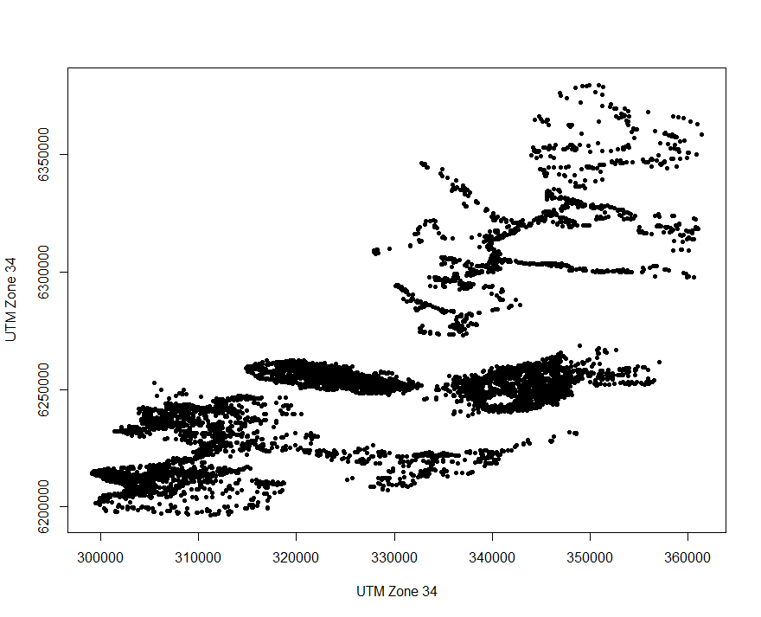

**Figure 3**

GPS locations of 14582 leopard individuals.

To use GLM Poisson SCR model, first we need to cut the location data into pixels, which representing the trap location xj in SCR model. We cut the data into 87 by 30, total 2610 pixels that contains all GPS location points in our data and then we calculate the total amount of individual observations in each pixel. We have minimum 0 count for leopard and maximum 448 count in our all pixels. In data processing part, we drop missing value in GPS location data and transfer the raw GPS information to UTM Zone 34 format (zone where leopard habitat in). Then we find the activity center for nine leopard species, by taking average of each of their GPS coordinate. These nine activity center is si in SCR model, where j is 1 to 9. We plot the pixel we cut form the GPS data with color represents the count in each pixel, and we add nine activity centers to the plot. The graph of elevation and landcover in pixel and centroid point also be plotted.

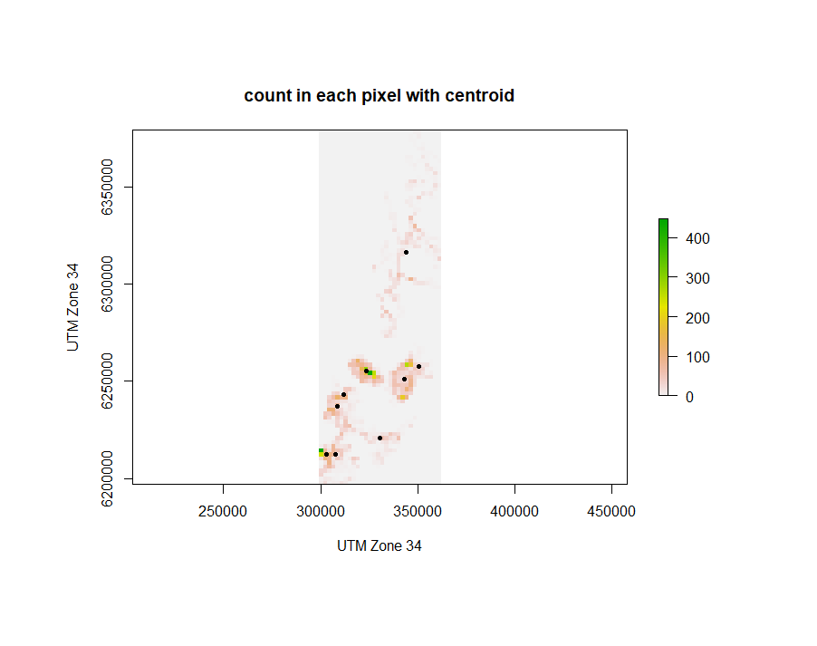

**Figure 4**

Activity center of eight leopard species and count of leopard for each pixel.

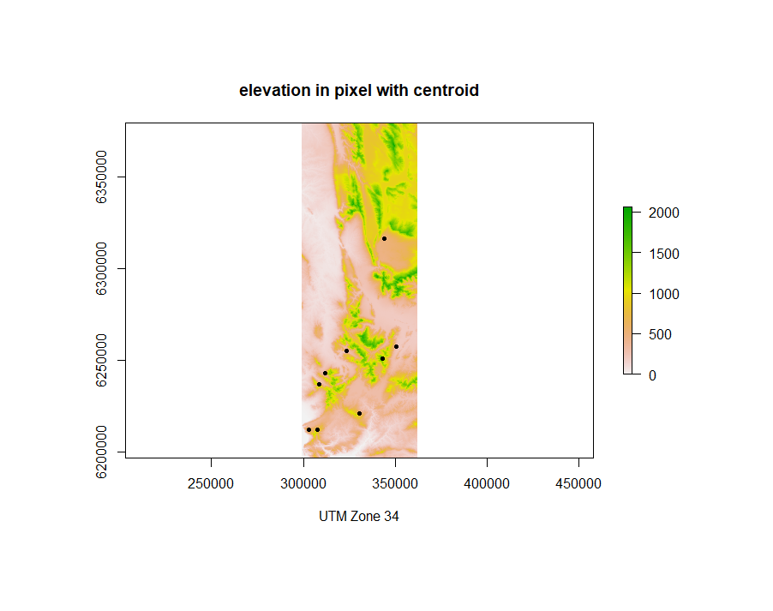

**Figure 5**

Activity center of leopard and elevation in each pixel.

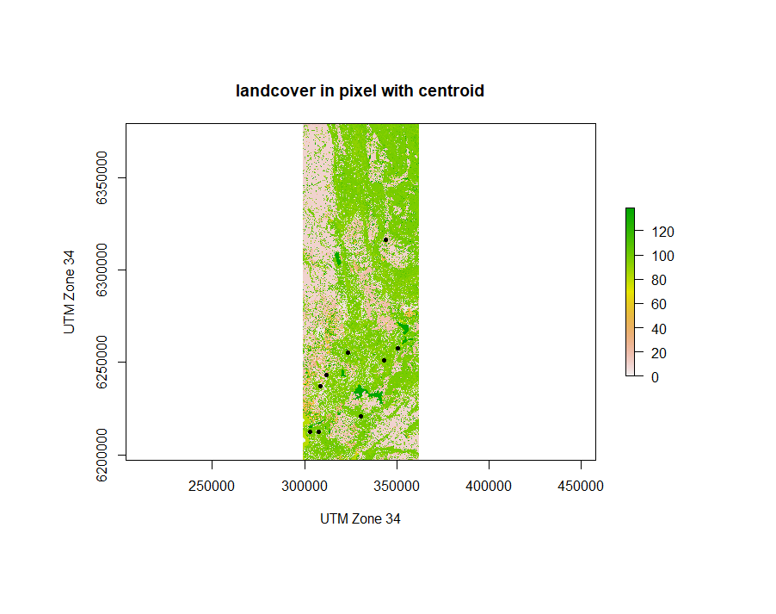

**Figure 6**

Activity center of leopard and landcover in pixel.

Based on Figure 4, the distribution of nine activity center is not symmetric or regular; most activity centers of leopard species are in the bottom of the area. And the home ranges, which tells by the color area around activity center, shows nine leopard species might have different space usage for different size of their home range. Eight species in the bottom of the area have less home range compared to the species on the top of that area. This shows we might need to add distance analysis for each leopard species. Figure 5 shows most leopard’s favorite area has elevation less 1000, and figure 6 shows leopard prefer landcover region to stay. The Euclidean distance from the centroid of each leopard species to each pixel location, which is dij in SCR model, is then added to the pixel data frame. Because these nine species have record in coincident pixels, it is hard to transfer location data of all night species together, so we transfer the observations of each nine leopard species to 2610 pixels data format (in each row record count of leopard in that pixel) separately and then combine these nine data frames together.

Basic Model

Now we have processed data contains 23490 row which connect to 2610 pixels and nine species; each row contains x, y-coordinates of center location (xj) in that pixel, the count of leopard in that pixel, the species name in that pixel, the distance (dij ) and landscape covariate elevation (z1) and landcover (z2). The basic model we use here is GLM Poisson model, based on the Poisson encounter model (eqn 8), which contains the distance dij and two landscape covariates z1 and z2 :

.

Then we make several models relate to the basic model including model with or without landscape covariates and model with single covariate. Here are the full models list:

Model 1: Basic Model - Basic encounter model with all terms.

Model 2: DModel - Model with only distance parameter.

Model 3: EModel - Model with distance and elevation parameter z1 (x).

Model 4: LModel – Model with distance and landcover parameter z2 (x).

During fitting Poisson model, we find large dispersion value for all these four models, therefore we change GLM model family to quasi-poisson to fit. Because of the usage of quasi-poisson, traditional AIC test is not work in our models; therefore, we use QAIC to test our models. The table below shows information in first four models:

**Table 1**. Summary of fitting models. Parameters include intercept 𝛼0 , coefficient of distance 𝛼1 , elevation 𝛼2  and landcover 𝛼3 is estimated. Their QAIC, p-value (p-v) and standard error (SE) are also in the table. Data contains 9 individuals and 2610 pixels for each individual.

|  |  |  |  |  |  |  |  |  |  |
| --- | --- | --- | --- | --- | --- | --- | --- | --- | --- |
| Model | 𝛼0 | p-v | 𝛼1 | p-v | 𝛼2 | p-v | 𝛼3 | p-v | QAIC |
| Basic | 3.85 | 2e-16 | -2.29e-4 | 2e-16 | 1.13e-4 | 0.635 | 3.19e-3 | 0.151 | 466.5 |
| SE | 2.59e-1 |  | 1.5e-5 |  | 2.37e-4 |  | 2.23e-3 |  |  |
| DModel | 4.176 | 2e-16 | -2.31e-4 | 2e-16 |  |  |  |  | 465.2 |
| SE | 1.62e-1 |  | 1.64e-5 |  |  |  |  |  |  |
| EModel | 4.064 | 2e-16 | -2.3e-4 | 2e-16 | 1.86e-4 | 0.436 |  |  | 466.6 |
| SE | 0.211 |  | 1.54e-5 |  | 2.38e-4 |  |  |  |  |
| LModel | 3.902 | 2e-16 | -2.29e-4 | 2e-16 |  |  | 3.39e-3 | 0.132 | 464.7 |
| SE | 2.42e-1 |  | 1.55e-5 |  |  |  | 12.25e-3 |  |  |

Based on the QAIC value, Lmodel with landcover covariate and the DModel are preferred. Parameter 𝛼3shows the encounter probability has positive response to landcover. Parameter 𝛼1 shows distance has negative effect on leopard space usage. This could be proved by the plots below.

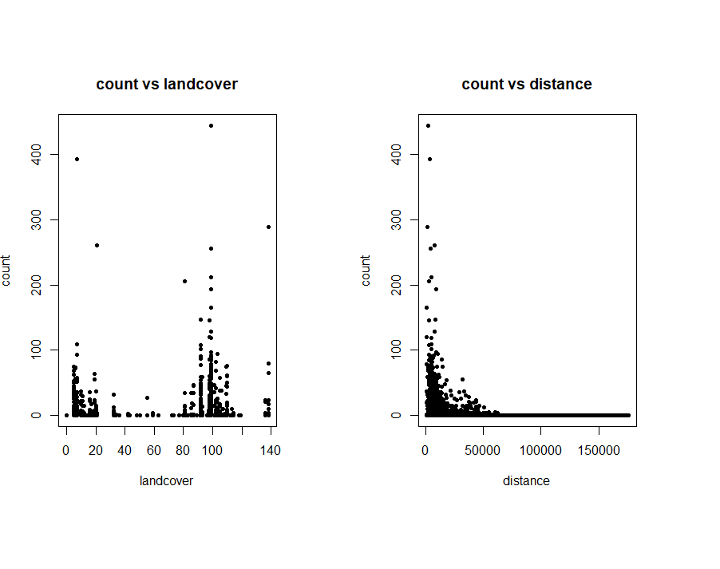

**Figure 7**

Count with landcover and distance plot. First plot shows

landcover has positive effect to count, second plot shows

distance has negative effect to count.

There exist two problems according to the table. First, the basic model which contains all landscape covariate parameters is not the preferred model in our table. This means elevation might has no relationship with encounter probability, which only depends on the distance and landcover parameter. Second, in the most preferred model LModel, landcover coefficient 𝛼3 has p-value that shows this parameter is not significant to the model. The reason for these problems appears in plots of count and distance. By plotting count and distance for each individual leopard separately, we notice the home ranges of individuals are different; distance and count plots of individual BM22 and BM4 show this problem clearly, BM22 has activity range 60000 and BM4 has range less than 10000. This could cause problem for distance parameter during fitting our model. Therefore, the interaction term of distance with individual factor should be added into our model.

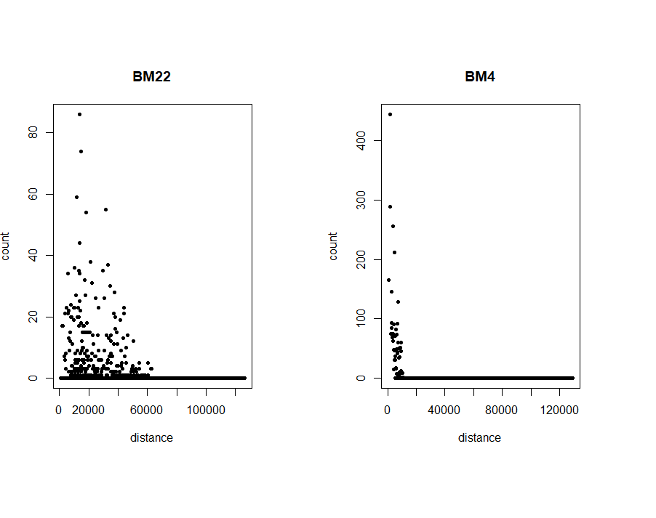

**Figure 8**

Plot of distance and count of BM22 and BM4.

**Interaction Model**

We add an interaction term of leopard individual factor and the distance to our basic model, to solve problem causes by individual home range variation. The New model is:

,

where $d^{2}\left(x\right) : cat(x)$ is the interaction term and cat(x) is the category of leopard individual here. The dispersion parameter is still large, so we use quasi-poisson model instead Poisson model. Based on the result of dredge function using QAIC test, the model contains interaction and two covariates is the most preferred model, with the lowest QAIC value. So, we will use this model as the final model in our study. The next plot shows the estimation of coefficient, p-value and standard error of our fitting model.

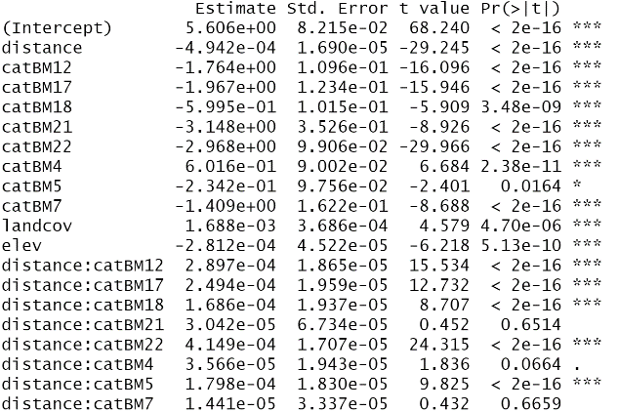

**Figure 9**

Parameter summary in basic interaction model.

In our model, all distance and two landscape covariates show strong significance here; this shows all distance and two landscape components are important for leopard’s space usage. The SE (standard error) of these three parameters reduce in this model. Distance has negative effect to individual usage and landcover has positive relationship with individual count as previous model without interaction term. It is interesting that the effect of elevation to individual usage changes to negative compared to previous model. The influence of the interaction term seems change the effect from the elevation.

In model diagnostic, the residual and fitted plot shows a straight line and points tend to have no non-linear trend, most points lie equally across the red line; this means there’s no discernible non-linear trend to residuals in our model. The Nomal-qq plot has no meaning here since our model is Poisson distribution. The Residuals vs Leverage plot shows most points stay inside the cook’s distance lines. We have four point lie outside redline shows high residual and high leverage. The Pearson residuals plot could do nonlinearity test for each parameter in our model. The quadratic smooth lines in residual plot show there is no nonlinearity since the curvature tends to be zero in all model covariates and the test statistic for coefficients relate to quadratic term are not very large. The model diagnostic plots and residual plots are in Appendix.

**Prediction**

We make the predictions of leopard count based on original data and our final model, including 9 leopard species and 23490 prediction counts in each pixel. We define the error of prediction and real count less than 0.5 in each pixel is accurate and larger than 0.5 to be inaccurate and get the accuracy of the prediction by our model is around 0.9063. The comparison of data and prediction graphs that plot count vs each covariate shows the effect of covariates to count is same in previous model analysis: And the trend in each plot proves the effect on individual count for each covariate, which we get from the fitting model above. The prediction plot shows most individual tend to move in area where elevation from around 50 to 700, and where landcover has value from 80 to 120.

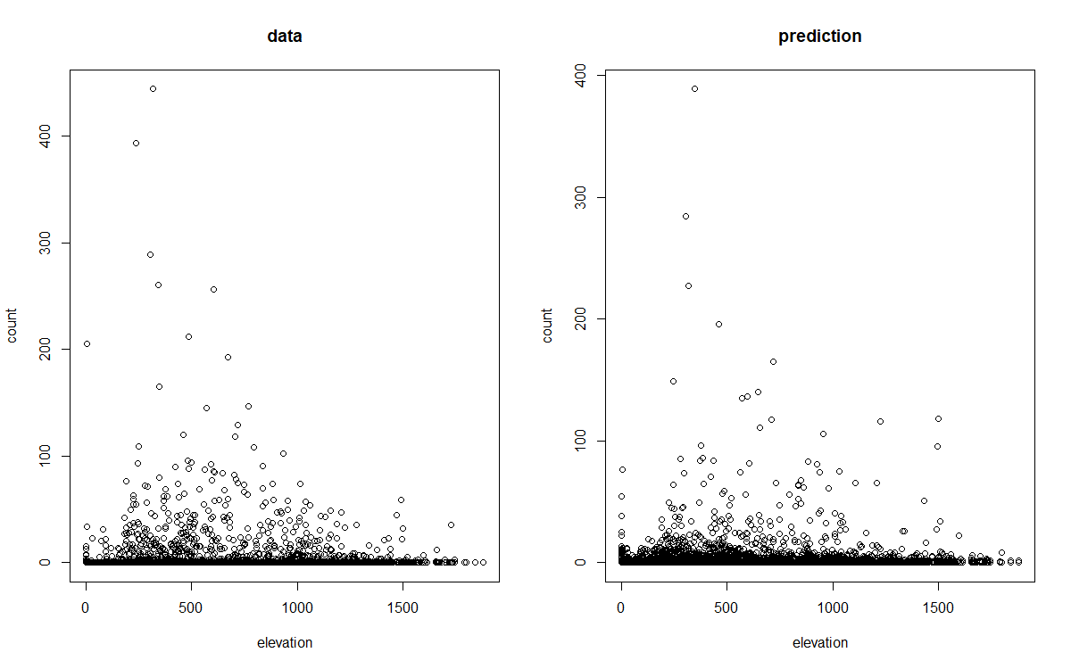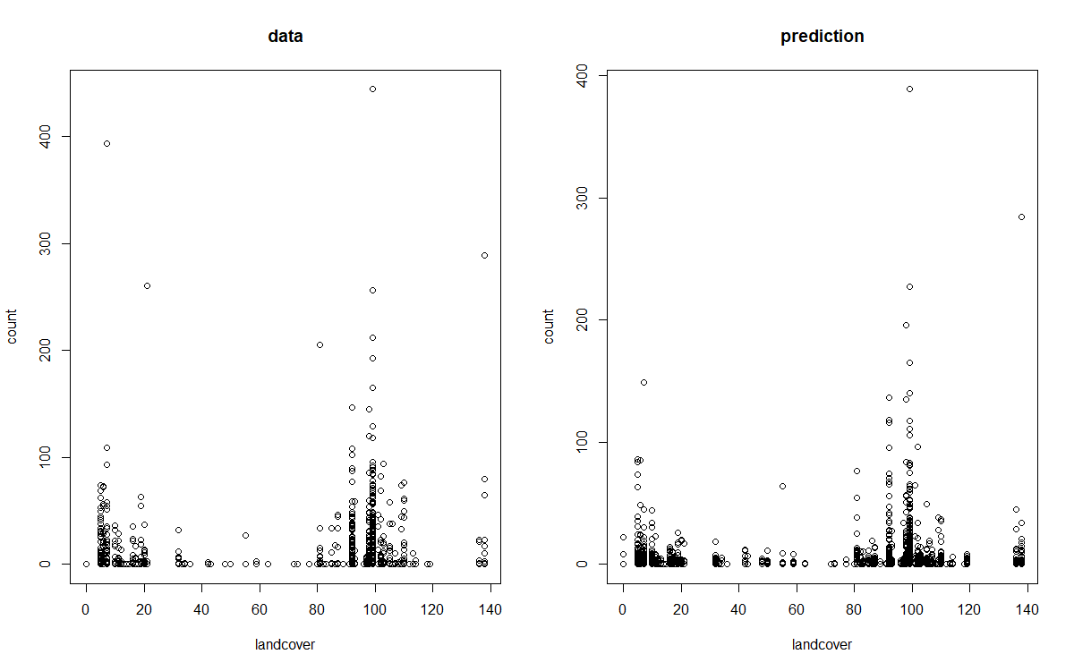

**Figure 10**

Comparison plot for count vs covariate.

The heatmap based on the predictions could show the effect of model, elevation and landcover component. Below are five pixel plots: the count in pixel plot of original data, count in pixel plot of prediction, the mean Pearson residuals and pixel plot of elevation and landcover.

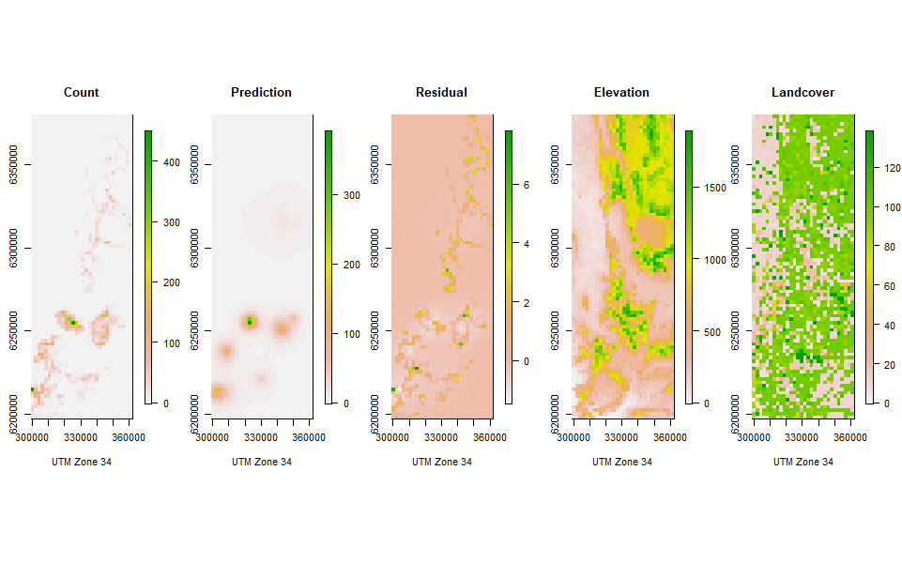

**Figure 11**

Five pixel plots

Based on these plots, most leopard species tend to live in area where the elevation and landcover are medium degree. One individual prefers to move in north area that is high elevation and high landcover. This individual has large home range and small number in pixels based on our predictions; for other individuals, they have less home range and high-density space usage in their home range. According to Pearson residuals, all species in north and south are predicted well by the model, the huge activity area for the north individual makes it has low density in each pixel. Furthermore, we find there exist connection in elevation and landcover components; those area with high elevation tend to have high landcover. In leopard’s home ranges, leopard tend to stay in high landcover area, and these areas could attract many herbivores such as zebra and antelope; therefore, these landcover area provide large amount of food for leopard species. During habitat protection process, ecologists should pay more attention to protect these regions; and the destruction of these area could cause biggest effect to leopard species.

**Discussion**

Understanding how animals use their habitat is important to Biologists and ecologists. Analysis of landscape components, which we focus in this paper, could help ecologists to target animals Habitat and activity area more efficiently, and help them reduce the habitat destruction. Research shows that the habitat destruction is recognized as the main reason to cause animal extinction at present. (Pimm & Raven, 2000) For endangered bird species, 82% of them are threatened by habitat loss. (Barbault & Sastrapradja, 1995) The habitat identification, which is one of the most important part in habitat protection, let human facilities building avoid important animal habitat. Understanding landscape component around habitat could provide additional information to the habitat, especially for those large space usage animals.

In our paper, we use the encounter probability model, based on the spatial capture-recapture model with landscape covariate analysis, to understand each landscape component’s effect to animal space usage. The significance of landscape parameter tells if this landscape component influence animal activity in it’s habitat; the sign of the coefficient of parameter shows the component has positive or negative effect to animals space usage; and the value of the coefficient interpret the degree of effect each component has. Once we have these information about environment element in habitat, we could make deeper understand to this region and protect this area better and faster.

**Leopard analysis**

The difference in animal species home range could affect the fitness and accuracy of our encounter model. In research of leopard, several different species have different home ranges, this causes the elevation and landcover covariate in our model show bad significance. The different home range could even affect the relationship between animal space usage and landscape covariate. We suggest that the encounter probability model is fitting with an interaction term of leopard species category and distance, and this could solve several problems causes by the difference of species home ranges. In result from our final encounter with interaction term, the standard error of all parameters in model decrease, compared with model without interaction term; and we have the model with all significant landscape parameters elevation and landcover; this means all elevation and landcover element associate with leopard activity. The leopards’ space usage is positively associated with elevation in previous model, but when we use interaction term model the elevation has negative effect to leopard space usage. The landcover coefficient has positive association with leopard count in both model without and without interaction term, and in final model the landcover has larger coefficient than elevation coefficient; this shows landcover component might has stronger effect to leopard than elevation component. The negative relationship between elevation and space usage indicates leopards dislike high elevation region, and positive relationship between landcover and space usage shows leopard prefer landcover area than no landcover area; access to the preys which live in landcover area and low elevation area might be the main reason to this association, and access to river or caves could be another reason. In those landcover region with relatively not high elevation, or near river and lake, there are many herbivores such as zebra and antelope; because of that, these areas attract leopard species by their large amount of food. These areas should be concerned more than other area, when human felicities allocation or wild area development. Destruction in these area could influence leopard seriously, even might decrease leopard species.

**Extension**

We develop the encounter probability model based on spatial capture-recapture model (Royle 2013b), to analyze landscape components in animal space usage. This model is able to add extension of landscape covariate when estimating individual encounter probability. We add interaction term to our model to deal with inequality of individual home range, and change family to quasi-poisson for huge dispersion parameter. In space usage study, we use our model to estimate individual’s space usage for each pixel, based on the distance of pixel location to individual activity centroid and some additional landscape covariates. To use this model, data should contain distance and landscape information for every pixel. Our model based on assumption that individual has random space usage for each pixel, which means the space usage in current pixel will not affect the usage in next pixel. This means our model is only sensitive to individual count and density in pixel, but unable to estimate the movement across different pixels. We use this model for independent observations study, and in which doesn’t exist individual dependent movement assumption. When the violation of independent assumption occurs, our model might lose huge accuracy and unable to work.

An improvement to our model is the movement analyzing model with extension of landscape component analysis, especially when individual movement is concerned in the study. Such model could be used for those dependent assumptions occur and could improve estimation of encounter probability by analyzing individual movement based on spatial capture-recapture model. The encounter model based on ecological distance metrices by Royle (2013 a) is one of good methods to improve the movement estimation in population study. In his model he uses least-cost path between traps with centroid to replace the Euclidean distance between two points, this makes the model work well in space usage study relate to animal movement. On the other hand, more landscape covariate added to the model might also be useful to improve the model accuracy.

**Conclusion**

Our model is able to work in research contains individual movement. We could use our encounter model based on spatial capture-recapture model to analyze the role of environment elements in animal space usage, under the independent activity assumption. The information based on the result in our encounter model could help ecologists understand how do landscape components animal space usage, and help to solve habitat protection problems such as designing animal sanctuary. Extension of individual movement with landscape covariate could be added in to improve our encounter model when animal space usage is dependent to some specific variables.